ST10529147
Neo Lebitsa

Table of contents
EDA
Feature selection
Interpreting the model
Conclusion 1

Analysis plan
Exploratory Data Analytics

Step 1: Importing required libraries.
Import Pandas,Seaborn and Matplotlib, numpy.

Step 2: Download and upload dataset.
Download the dataset as the csv file and upload it to the Jupyter notebook.

Step 3: Structure and size
The dataset consists of 32 columns and 569 rows which contain enough data for analysis. The data is structured and easy to analyse.

Step 4: Data types

Column name | Description | Data type
id | Numerical | Independent(integer64)
diagnosis | Category | Independent (object64)
raduis_mean | Numerical | Independent (float64)
texture_mean | Numerical | Independent (float64)
perimeter_mean | Numerical | Independent (float64)
area_mean | Numerical | Independent (float64)
snoothness_mean | Numerical | Independent (float64)
compactness_mean | Numerical | Independent (float64)
concavity_mean | Numerical | Independent (float64)
Concave points_mean | Numerical | Independent (float64)
symmetry_mean | Numerical | Independent (float64)
fractal_dimension_mean | Numerical | Independent (float64)
radius_se | Numerical | Independent (float64)
texture_se | Numerical | Independent (float64)
perimeter_se | Numerical | Independent (float64)
area_se | Numerical | Independent (float64)
snoothness_se | Numerical | Independent (float64)
compactness_se | Numerical | Independent (float64)
concavity_se | Numerical | Independent (float64)
Concave points_se | Numerical | Independent (float64)
symmetry_se | Numerical | Independent (float64)
fractal_dimension_se | Numerical | Independent (float64)
radius_worst | Numerical | Independent (float64)
texture_worst | Numerical | Independent (float64)
perimeter_worst | Numerical | Independent (float64)
area_worst | Numerical | Independent (float64)
snoothness_worst | Numerical | Independent (float64)
compactness_worst | Numerical | Independent (float64)
concavity_worst | Numerical | Independent (float64)
Concave points_worst | Numerical | Independent (float64)
symmetry_worst | Numerical | Independent (float64)
fractal_dimension_worst | Numerical | Independent (float64)

Step 5: Missing and duplicate values
The dataset has no missing and duplicate values.

Step 6: Outliers
Kkjj

Step 7: Value distribution
There is a significant variance in the dataset values.

Step 8: Bias representation
The dataset covers all the required categories.

Feature selection
The following columns will be used as predictors (all the x feature_names). The charges are the outcome of the predictions. The pairplot will be constructed to determine which parameters have the linear relationship. Therefore x feature_names will be used as the x-variable and diagnosis as the y-variable. The p value, correlation targets and the variance will be considered when choosing the models.

Train model
The model will be trained using the Logistic regression model.80% of the dataset will be used to train the model and 20% of the dataset will be used to test the data. The dataset contains about 569 rows and 32 columns, which is suitable for training and testing the model with 20%.

Interpreting the model

The dataset consists of 569 rows and 32 columns, and contains no duplicates or null values. The datatypes on the dataset are float and object. The graph below shows that 357 individuals were diagnosed with Benign cancer while the other 212 individuals were diagnosed with Malignant cancer, this is depicted by Figure 1. The id column was removed from the dataset as it had no significant effect on the model’s performance. Figure 2 shows the correlation between the independent input features and the dependent outcome target.
There is a linear relationship portrayed by radius_mean, perimeter_mean and area_mean. This shows multicollinearity between independent features, which affect the training of the model and results in bias as well as unstable standard error and p-values. Radius_mean and radius_worst, and all the worst variables also have high correlation. Therefore, all these input features will be dropped and not used in training the model. Figure 3 shows the correlation after the multicollinearity was removed, therefore, the bias and the significant effect that could have been caused by multicollinearity has been reduced (Vatcheva, P.k., Lee, M., McCornick, J.B., Rahbar, M.H, 2016).

Attached below is the model outcome. It shows that the model is accurate and precise(0.97). It predicted Benign cancer accurately with a probability of 1.00. Moreover, the F-score value is 0.99, which shows precision when recalling the datapoints. For Malignant cancer the model performed well with precision of 1.00, F-score of 0.99 and 1.00 recall. All these attributes collaboratively show that the model learned from the hidden parts and has no bias. Logistic regression performed well with 0.98 accuracy level, this shows that the model fits the dataset almost perfectly. However, the model can be slightly modified to increase its accuracy and enhance its performance in real life. From the 0.2 testing data, the model predicts 71 individuals as Benign patients and 43 as Malignant patients.

precision recall f1-score support

B 0.97 1.00 0.99 71
M 1.00 0.95 0.98 43

accuracy 0.98 114
macro avg 0.99 0.98 0.98 114
weighted avg 0.98 0.98 0.98 114

0.9824561403508771

Conclusion
The model performed well with 0.98 accuracy level. This is a good indication that the input features used when training the model were effective.

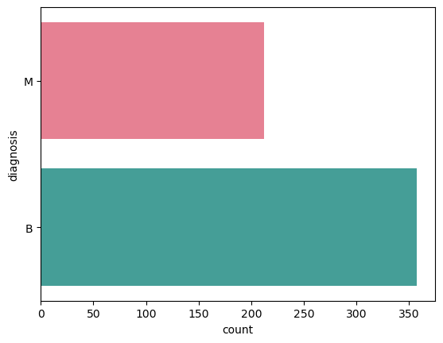
Figure 1: Graph of number of individuals with Malignant and Benign cancer.

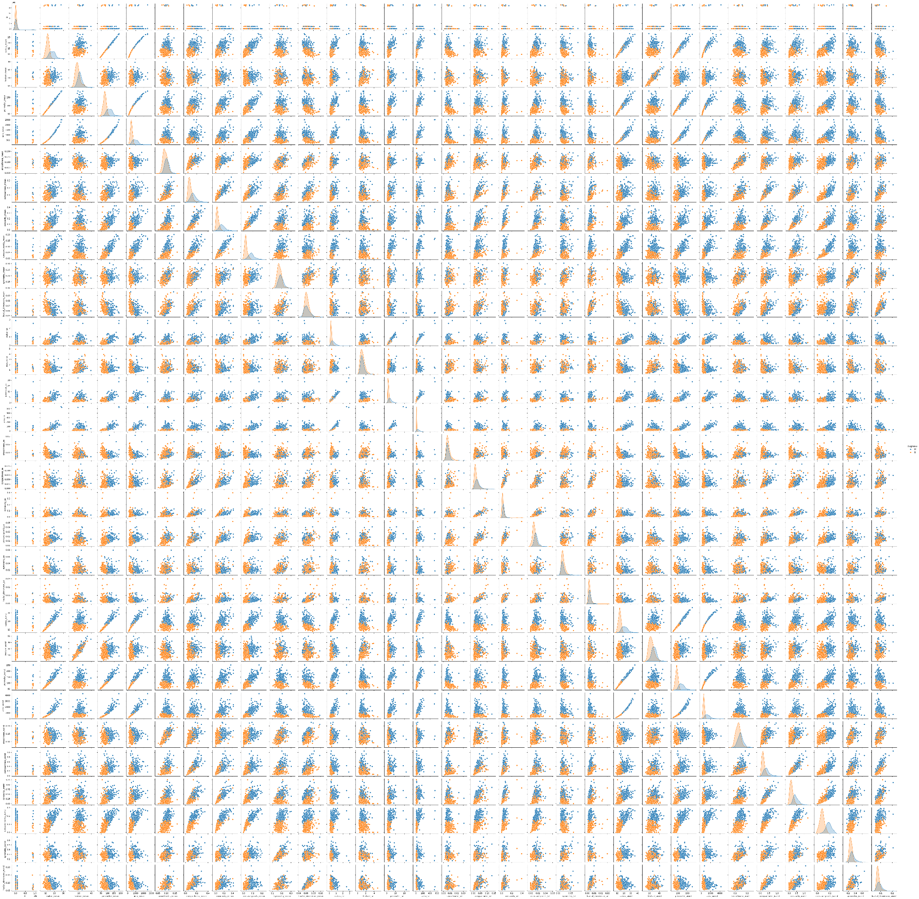
Figure 2: Pairplot of the breast-cancer dataset.

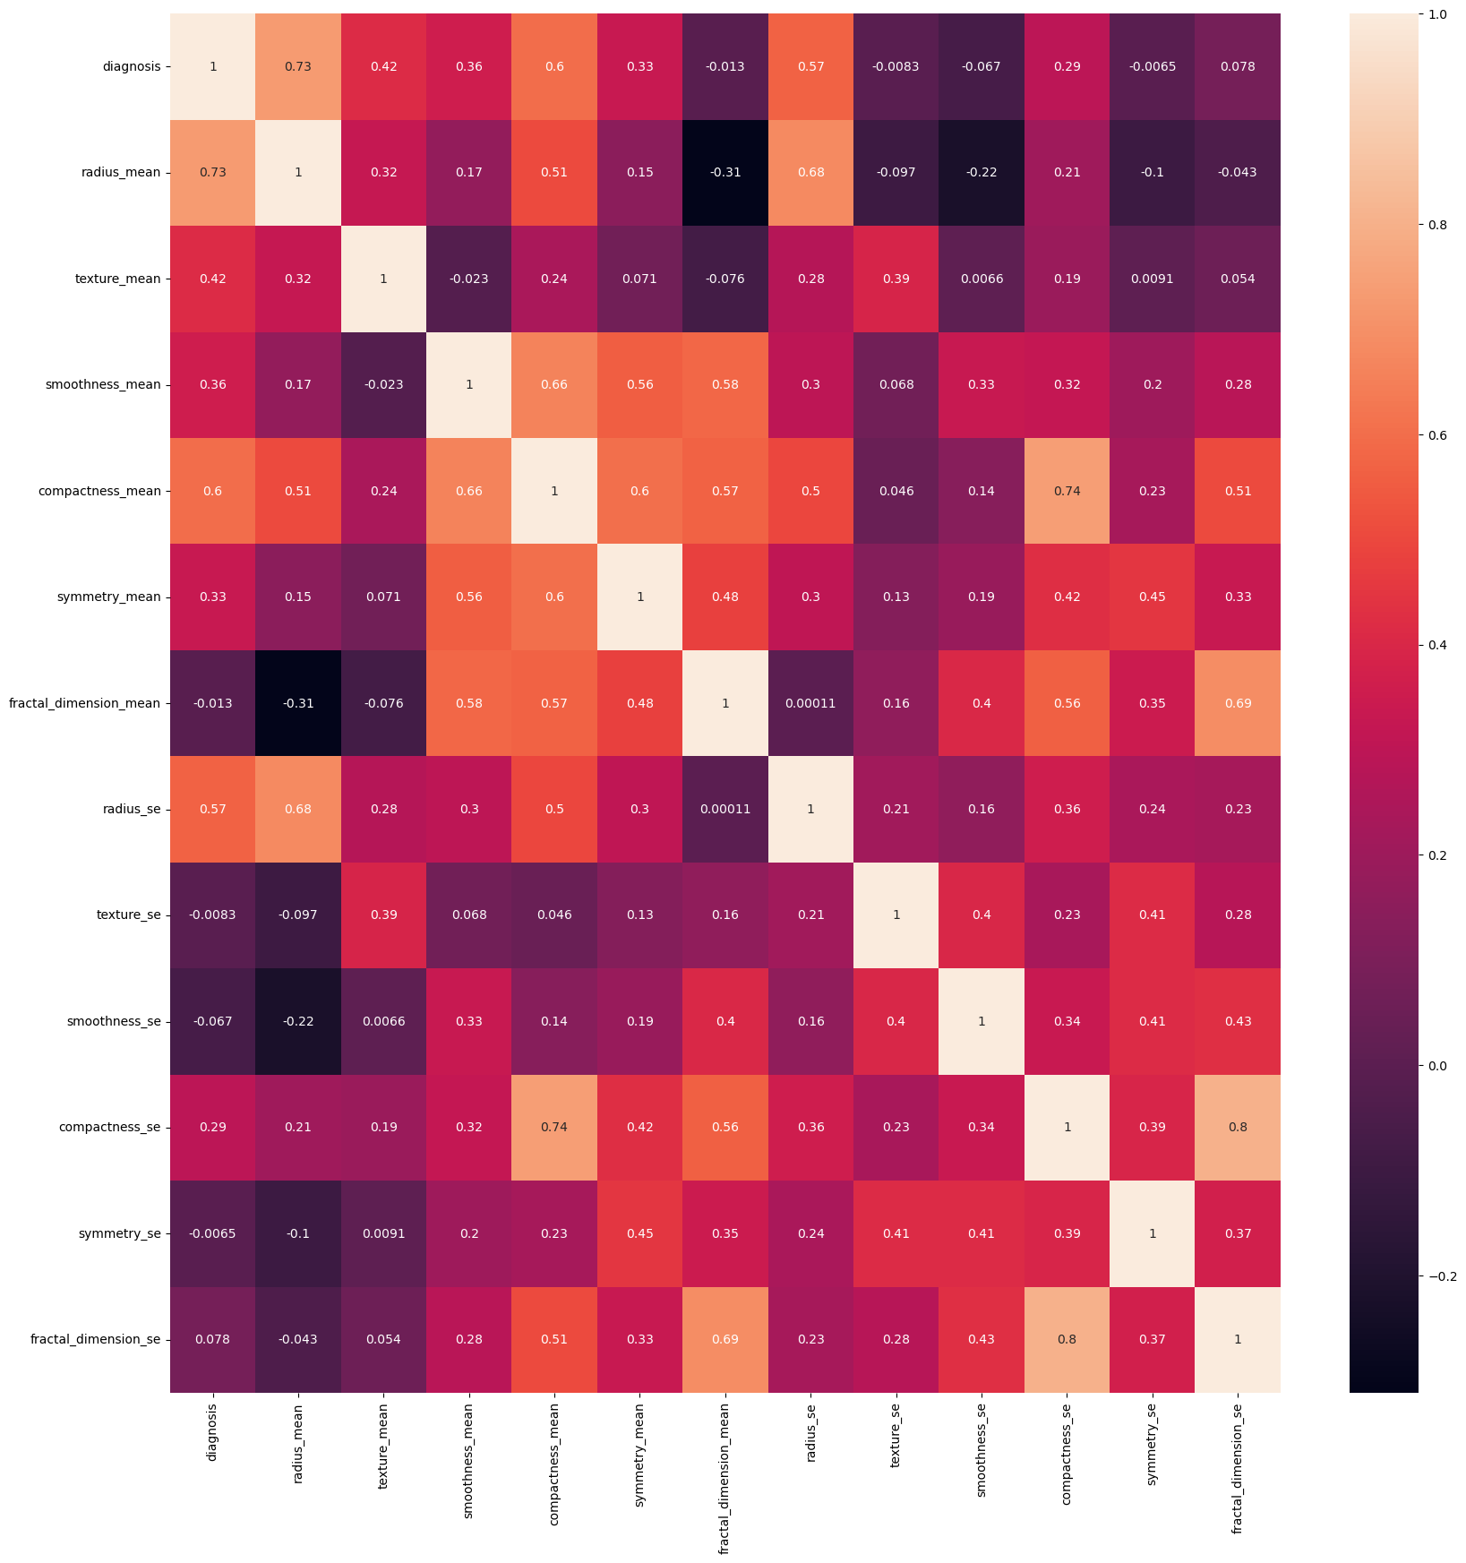

Figure 3: Correlation between input features and the target.

Reference
Vatcheva, P.k., Lee, M., McCornick, J.B., Rahbar, M.H. 2016. Epidemiology (Sunnyvale). Author manuscript; available in PMC: .Published in final edited form as: Epidemiology (Sunnyvale).;6(2):227.
doi: 10.4172/2161-1165.1000227
Microsoft. (2026). Copilot [AI companion]. Microsoft. https://copilot.microsoft.com

